**Hands On – 4**

Please follow the instructions to complete the hands-on. Each instruction expect a command for the Git Bash.

1. Verify if master is in clean state.
2. Create a branch **“GitWork”.** Add a file “hello.xml”.
3. Update the content of “hello.xml” and observe the status
4. Commit the changes to reflect in the branch
5. Switch to master.
6. Add a file **“hello.xml”** to the master and add some different content than previous.
7. Commit the changes to the master
8. Observe the log by executing **“git log –oneline –graph –decorate –all”**
9. Check the differences with Git diff tool
10. For better visualization, use P4Merge tool to list out all the differences between master and branch
11. Merge the bran to the master
12. Observe the git mark up.
13. Use 3-way merge tool to resolve the conflict
14. Commit the changes to the master, once done with conflict
15. Observe the git status and add backup file to the .gitignore file.
16. Commit the changes to the .gitignore
17. List out all the available branches
18. Delete the branch, which merge to master.
19. Observe the log by executing **“git log –oneline –graph –decorate”**

**Execution:**

**1)Verifying if master is in clean state**

**Command:**

git status

**Output:**



**2. Creating a branch “GitWork” & add hello.xml**

**Command:**

git checkout -b GitWork

echo "<message>Hello</message>" > hello.xml

git add hello.xml

git status

**Output:**



**3) Updating the content of “hello.xml” and observing the status**

**Command:**

echo "<message>Hello updated</message>" > hello.xml

git status

**Output:**



**4) Commiting the changes in branch**

**Command:**

git add hello.xml

git commit -m "Added hello.xml"

**Output:**



**5) Switching to master**

**Command:**

git checkout master

**Output:**



**6) Adding hello.xml in master with different content**

**Command:**

echo "<message>Hello from master branch</message>" > hello.xml

git add hello.xml

**Output:**



**7) Commiting changes in master**

**Command:**

git commit -m "Added hello.xml in master branch"

**Output:**

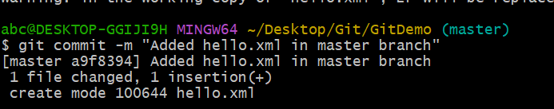

**8) Observing log**

**Command:**

git log --oneline --graph --decorate –all

**Output:**



**9) Checking differences**

**Command:**

git diff master GitWork

**Output:**



**10) Using P4Merge for better visualization**

**Command:**

git merge GitWork

**Output:**



**11. Merge branch into master**

**Command:**

git merge GitWork

**Output:**

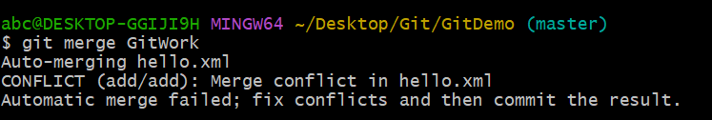

**12) Observing Git markup**

**Command:**

git status

**Output:**



**13) Using 3-way merge tool to resolve conflicts**

**Command:**

git mergetool

**Output:**

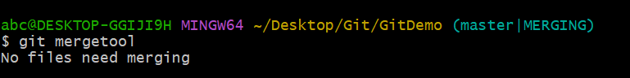

**14) Commiting resolved changes**

**Command:**

git add hello.xml

**Output:**



**15) Adding backup files to .gitignore**

**Command:**

echo "*.bak" >> .gitignoregit status

git status

**Output:**



**16) Commiting .gitignore**

**Command:**

git add .gitignore

git commit -m "Added gitignore"

**Output:**

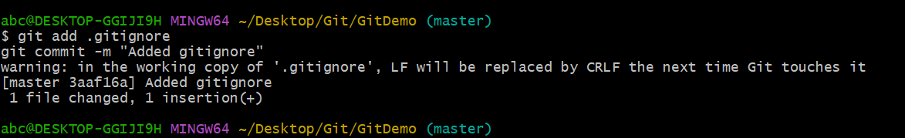

**17) Listing all branches**

**Command:**

git branch

**Output:**



**18) Deleting merged branch**

**Command:**

git branch -d GitWork

**Output:**



**19) Observing log again**

**Command:**

git log --oneline --graph –decorate



**GitLab Repo Url:**  
https://gitlab.com/teja272004/gitdemo